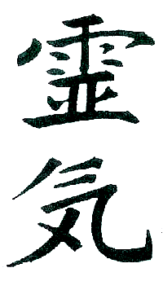
MAIL TO:
Sue Purdy
1919 Ursinus Avenue
Lancaster, PA 17603
Sue Purdy
Reiki Teacher/Master
717 201 3570
Sue_Purdy@purdyreiki.com

REIKI MASTER/TEACHER CLASS REGISTRATION

Location of Class 259 N. 6th Street, Suite 2, Columbia (unless otherwise indicated)

OR:

Date of Class

PRINT NAME
(as you want it to appear on your certificate)

Address

City/State/Zip

Telephone Cell

Email address

Birthdate
(month & day is fine)

Please use additional paper to answer these questions as needed:

What significant experiences have you had since being attuned to Reiki II? With people? With animals? With plants? With Distance Reiki? With self healing?

What is your interest in Reiki Master/Teacher Level? At this point are you planning to teach others and pass attunements?

Name 5 ways you use Reiki in your daily life.

Fee is $375. Registration and a deposit of $50 are due at least two weeks before class.
The balance can be paid the day of the class

