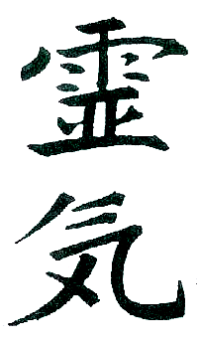

Sue Purdy
1919 Ursinus Avenue
Lancaster, PA 17603
Sue Purdy 717 201 3570
Sue_Purdy@purdyreiki.com

REIKI I CLASS REGISTRATION

Location of Class 259 N 6th Street, Suite 2, Columbia (unless otherwise indicated)

OR:

Date of Class

PRINT NAME

As you want it to appear on your REIKI I certificate
Address

City/State/Zip

Telephone Cell

Email address

Birthday (day and date are fine) __________

Have you ever had a Reiki session before? When? Are there any unique healing experiences you have had with Reiki?

Have you been attuned to any levels of Reiki prior to this? If so which ones, and by whom?

What is your interest in Reiki? What moved you to seek attunement?

Are you trained in other forms of healing techniques? If so, what?

